Dataset - AirBnB data for Manchester UK

This document walks through the steps to a clean version of the AirBnB data that you can use as data for your data journalism portfolio. The aim was to create a file that could be analysed and visualised with a minimum of issues. However, you should familiarise yourself with the process. Each data set will require some cleaning and adjustment. The key is to be purposeful with each step.

The data comes from AirBnB - https://insideairbnb.com/ This is not official data, its been scraped from listings. That means a computer program has been used to visit listings and harvest data. A lot of the data in the sheet relates to the process of collecting the data.

Step 1: Convert the CSV file (and correct formatting issues) 2
Why? 2
Step 2: Correcting formatting - Text or numbers? 2
Why? 3
Step 3: Remove unwanted text: $ signs 4
Why? 5
Further cleaning 5

Step 1: Convert the CSV file (and correct formatting issues)
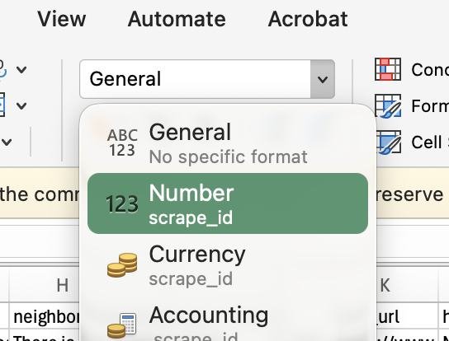
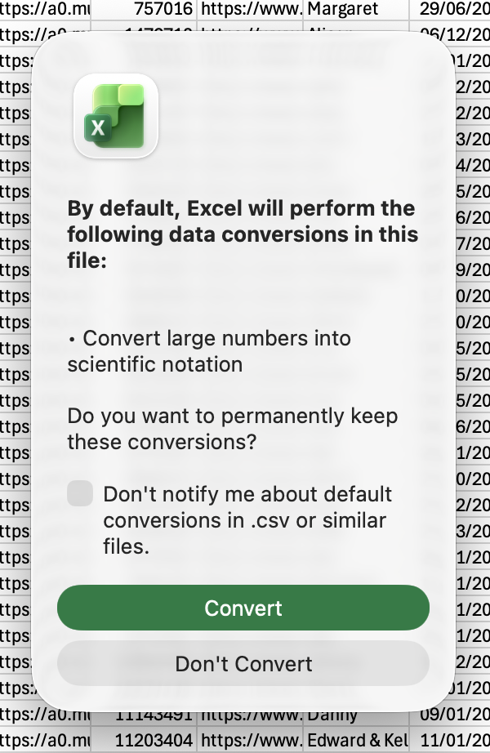

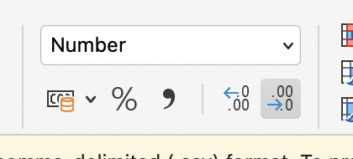

- Open the listings.csv file using Excel
- Select Don’t Convert when prompted
- Select Column C
- In the Home menu bar, select Number from the Format drop-down
- With Column C still selected, press the Decrease Decimal button twice to remove the trailing .00

Why?
CSV files store the data as structured text. When we import into Excel, it tries to be helpful and add formatting. One common type of formatting is to display long numbers in scientific notation. In this case, the ScrapeID is the victim of helpful Excel!

In the original, this is 14-digit number. Excel displays this in scientific notation 2.02509E+13. The original number is retained, but it’s not always helpful to have it hidden away. So, changing the display to force it to show the whole number is good practice to avoid problems. By default, Excel also adds 2 decimal places. We don’t need that. But again, it’s worth noting what the original data is so that we can check if we are creating rounding errors.

Step 2: Correcting formatting - Text or numbers?
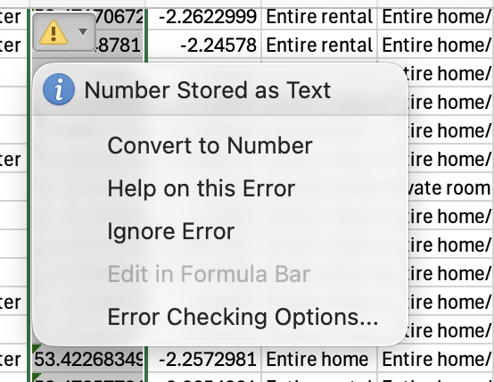
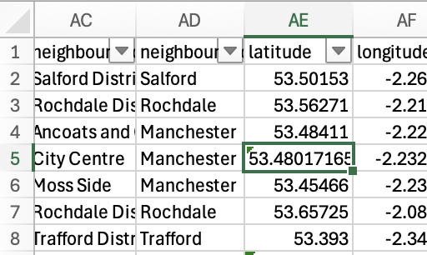
- Find and select Column AE named latitude
- Select Cell AE5 - it’s the first one with the small green triangle in the corner.
- Click Ctrl + Shift + down arrow. This will select the rest of the cells in the column.
- Click the warning triangle next to AE5
- Click Convert to Number.
- Any numbers as text will be converted.

Why?
Just like in Step 1, we’re correcting a common formatting issue that might cause us problems later down the line. This column contains co-ordinates that might be useful in mapping our data, so we need the numbers to be correct and want to be sure we don’t add numbers or decimal places - that would change the co-ordinates.

Step 3: Remove unwanted text: $ signs
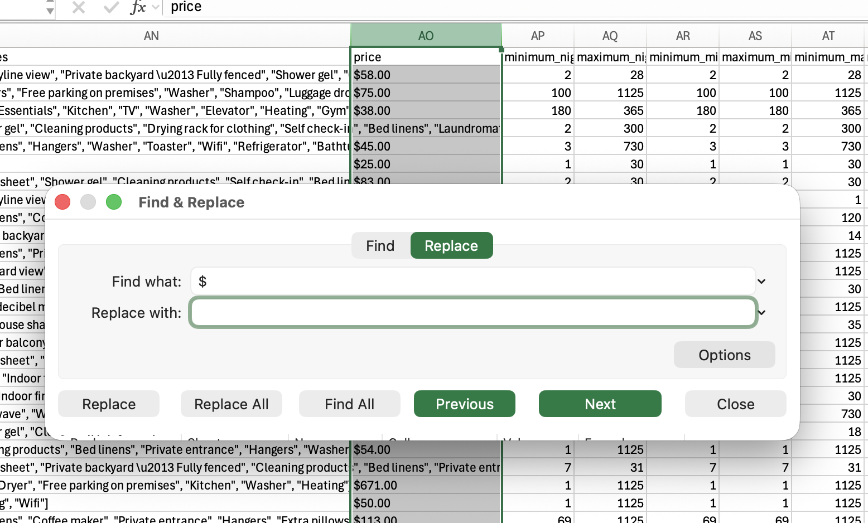
- Find and select Column AO named price
- Select Edit > Replace
- Add the $ sign to Find what:
- Leave the Replace with: blank
- Click Replace all.
- All the $ signs will be removed from the price column.

Why?
It’s not uncommon when data is scraped, for weird symbols and other artefacts to creep into the text. Cleaning data often means spending some time removing these. In this case the $ would be something we’d want to get rid of as its not a number and it might confuse our sums. But we always have to think carefully about why it’s there. Does it mean the costs are in $? Would I need to do some conversion? Does it actually mean Dollar, or is it an indicator of something else?

Checking the notes from the data, it turns out that it’s an error: daily price in local currency. NOTE: the $ sign is a technical artifact of the export, please ignore it.

So, in this case, it’s fine to get rid of it. But we still need to be careful. We can get rid of it here. But what if we delete it from somewhere else by mistake? Somewhere it might be needed.

To avoid this, it’s often worth doing a visual check to see where else it might pop up. To do that, you can use conditional highlighting to identify cells where it might pop up.
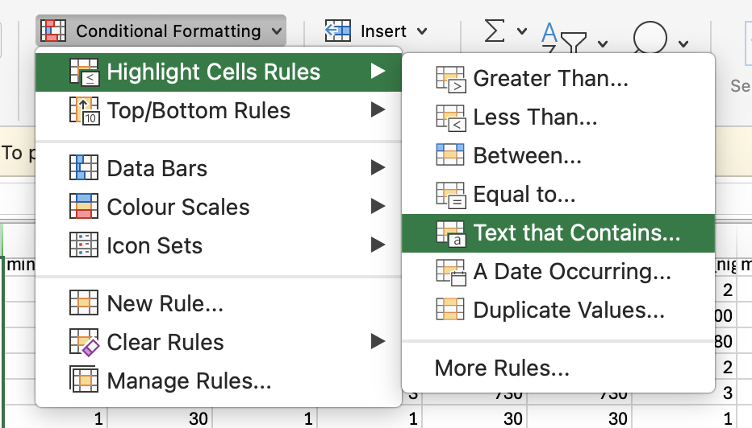
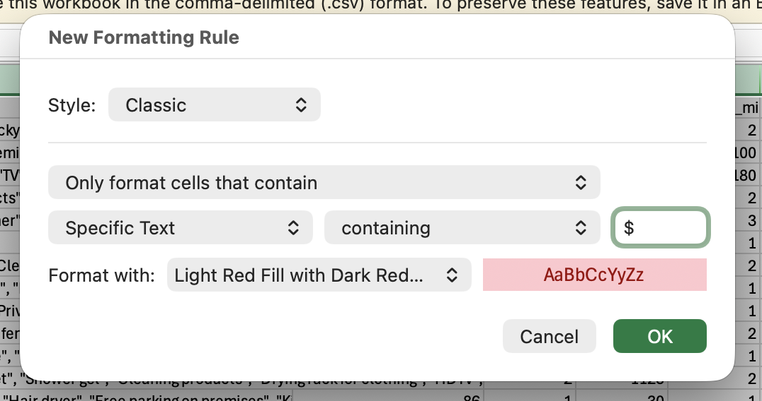
- Select the whole sheet
- Open the Conditional Formatting drop-down
- Select Highlight cell rules > Text that Contains…
- Add $ to the Specific text: Containing text box
- Click OK

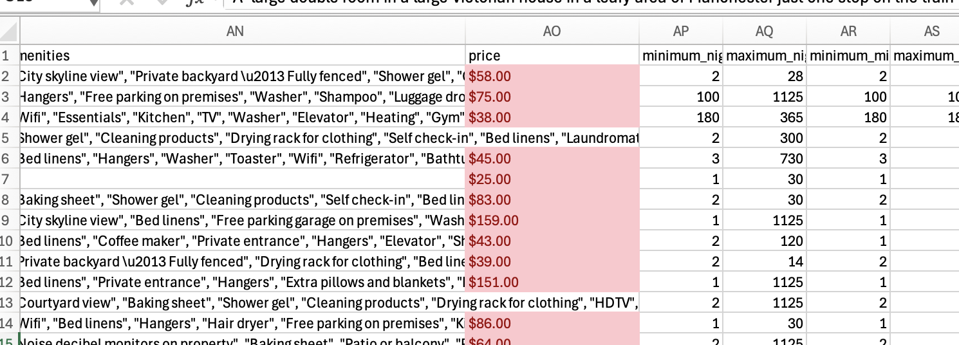

The cells containing a $ are highlighted and you can scroll through or zoom out on the sheet to see if there are any stray cells highlighted.

Further cleaning
It’s worth noting that there are lots of cells with dirty data. The neighborhood_overview cells, for example, are sprinkled with HTML - it’s not the only one. Many of the cells have special characters like emojis or icons that haven’t survived being converted to a CSV file. In an ideal world, we would want to get rid of that. For now, the numbers look pretty solid. So we can work with what we have.

